TRAFFIC VOLUME PREDICTION USING MACHINE LEARNING
A MINOR PROJECT-I
Submitted in Partial Fulfillment of the Requirement for the Award of the Degree of
BACHELOR OF TECHNOLOGY IN
COMPUTER SCIENCE & ENGINEERING-DATA SCIENCE SUBMITTED TO

Rajiv Gandhi Proudyogiki Vishwavidyalaya, Bhopal (M.P.)

SUBMITTED BY
Nandini Soni (0176CD231095)
Pragati Pandey(0176CD231104)
Tanishka Saxena(0176CD231146)

UNDER THE SUPERVISION OF
Prof. Reeta Bourasi
Department of Computer Science & Engineering-Data Science


Department of Computer Science & Engineering-Data Science Lakshmi Narain College of Technology Excellence, Bhopal (M.P.)
December 2025


Lakshmi Narain College of Technology Excellence, Bhopal

Department of Computer Science & Engineering-Data Science

CANDIDATE’S DECLARATION

We, Nandini Soni (0176CD231095), Pragati Pandey (0176CD231104), Tanishka Saxena(0176CD231146), Student of Bachelor of Technology, Computer Science & Engineering-Data Science, Lakshmi Narain College of Technology Excellence, Bhopal session 2025-26 hereby declare that the work presented in the Minor Project-I entitled “Traffic Volume Prediction System Using Machine Learning” is outcome of our own Bonafide work, which is correct to the best of our knowledge and this work has been carried out taking care of Engineering Ethics. The work presented does not infringe any previous work and has not been submitted to any University for the award of any degree / diploma.

we also declare that “A check for plagiarism has been carried out on the Minor Project-I and is found within the acceptable limit and report of which is enclosed herewith”.

Nandini Soni (0176CD231095)
Pragati Pandey (0176CD231104)
Tanishka Saxena(0176CD231146)


Lakshmi Narain College of Technology Excellence, Bhopal

Department of Computer Science & Engineering-Data Science CERTIFICATE
This is to certify that the work embodies in this Minor Project-I entitled “ Traffic Volume Prediction System Using Machine Learning” being submitted by “Nandini Soni (0176CD231095) , Pragati Pandey(0176CD231104) , Tanishka Saxena(0176CD231146) ” for partial fulfillment of the requirement for the award of degree of “Bachelor of Technology in Computer Science & Engineering-Data Science” discipline to “RAJIV GANDHI PROUDYOGIKI VISHWAVIDYALAYA, BHOPAL (M.P.)” during the academic year 2025-26 is a record of real piece of work, carried out by them under my supervision and guidance in the “Department of Computer Science & Engineering-Data Science”, Lakshmi Narain College of Technology Excellence, Bhopal (M.P.)

SUPERVISED BY FORWARDED BY

Prof. Reeta Bourasi
Department of CSE-Data Science LNCTE, Bhopal
Prof. (Dr.) Neetesh Kumar Gupta (Head, Department of CSE-Data Science)
LNCTE, Bhopal

APPROVED BY

Dr. Anil Kumar Saxena Principal
LNCTE, Bhopal

ACKNOWLEDGEMENT

At the outset, we would like to link to thank the Almighty who made all the things possible. Writing this project report would not have been possible without the support of several people whom we need to wholeheartedly thank. We express a deep sense of gratitude to our supervisor “Prof.Reeta Bourasi”, Dept. of CSE-Data Science for the valuable and inspirational guidance from the initial to the final level that enabled us to develop an understanding of this Project work.
we would like to give our sincere thanks to Prof. (Dr.) Neetesh Kumar Gupta, Head, Dept. of CSE-Data Science for their kind help, encouragement and co-operation throughout our Project period and we owe our special thanks to Principal Dr. Anil Kumar Saxena for their guidance and suggestions during the Project work.
Lastly, we want to thank our parents, friends and to all those people who had contributed to our project directly or indirectly for their moral and psychological support.

Nandini Soni (0176CD231095)
Pragati Pandey (0176CD231104)
Tanishka Saxena(0176CD231146)

Abstract
CONTENT

Page No.
1

Chapter 1 Introduction............................................................................. 2-5
  - Motivation......................................................................................…………….. 2
  - Scope.................................................................................................................... 3
  - Objective.............................................................................................................. 4
  - Application……………………………………………....................................... 5
Chapter 2 Literature Survey............................................................................... 6-8
  - Literature Survey………………………………………………………………. 6
  - Summary……………………………………………………………………… 8
Chapter 3 Problem Statement.................................................................. 9-10
  - Problem Statement................................................................................................. 9

Chapter 4 Minimum Hardware and Software Requirements................
  - Minimum Software Requirement…….…………………………………………
  - Minimum Hardware Requirement.........................................................................
Chapter 5 Methodology Used..................................................................
11-13
11
13
14-17

  - Method………………………………………………………………………… 14
  - Algorithm Used……………………………………………………………...... 16
Chapter 6 Design Framework…………………..................................... 18-23
  - System Architecture……………………………………………………………. 18
  - Data Flow Diagram …………………………………………………………… 20
  - Use Case Diagram…………………………………………………….………. 22
  - Block Diagram……………………………………………………………….. 23
Chapter 7 Implementation...................................................................... 24-31
7.1 Data Set Collection and Preparation…………………………………………. 24
7.2 Model Development and Selection ………………………………………….. 25
7.3 System File Structure………………………………………………………… 25
7.4 Backend Implimentation……………………………………………………… 25
7.5 Frontend Implimentation……………………………………………………… 26
7.6 Integration of frontend backend………………………………………………. 26
7.7 Challenges in Implimentation…………………………………………………. 27
7.8 Snapshot................................................................................................................. 28
Chapter 8 Testing....................................................................................... 32-37
  - Testing.................................................................................................................. 32
Chapter 9 Conclusion & Future Scope ………........................................... 38-39
9.1 Conclusion…………………………………………………………….. 38
9.2 Future Scope………………………………………………………….. 39

References
40-41

ABSTRACT

Traffic congestion has become one of the major challenges in rapidly growing urban environments. With increasing numbers of vehicles on the road each year, cities require intelligent solutions that can analyze traffic patterns and provide accurate predictions to support effective transportation planning. Traditional traffic monitoring systems mainly rely on manual observation or hardware-based sensors, which often fail to offer real-time insights or predictive capabilities. To address these limitations, this project presents a Machine Learning–based Traffic Volume Prediction System that analyzes historical traffic data along with weather and time-related factors to forecast hourly traffic volume.

The proposed system utilizes a public traffic dataset collected from Minnesota, USA, containing key parameters such as temperature, rain, snow, cloud coverage, time of day, and recorded vehicle count. After performing extensive data preprocessing, exploratory data analysis (EDA), feature engineering, and model comparison, the Random Forest Regression model was selected due to its superior performance over Linear Regression and XGBoost models. The system is integrated into an interactive Streamlit dashboard, allowing users to input real-time weather and time conditions to obtain immediate traffic predictions, classified into Low, Medium, or High traffic levels based on defined thresholds.

This project demonstrates how data-driven approaches can significantly improve traffic forecasting accuracy and support urban traffic management. The developed dashboard is user-friendly, visually intuitive, and provides actionable insights for commuters, city planners, and researchers. Future enhancements may include live data integration, geolocation-based predictions, and deployment as a mobile or cloud application.

CHAPTER 1: INTRODUCTION

Motivation

In major urban cities, traffic congestion has become an unavoidable daily challenge, affecting millions of people. Rapid urbanization, increased vehicle ownership, and limited road expansion have placed enormous pressure on transportation networks. As a result, commuters face prolonged delays, unpredictable travel times, fuel wastage, and higher environmental pollution. Traditional traffic monitoring systems rely mainly on static sensors, CCTV surveillance, or manual counting, which only provide real-time updates and fail to anticipate future traffic conditions.
This absence of predictive insight makes it difficult for commuters to plan optimal routes and poses challenges for traffic authorities attempting to regulate flow during peak hours, special events, or adverse weather conditions.

With the advancement of machine learning and data analytics, it has become possible to identify complex patterns hidden within large traffic datasets. By analyzing the relationships between weather, time, and historical traffic counts, these models can accurately forecast future traffic trends.
The motivation behind this project is to build a smart, data-driven traffic prediction system that not only estimates hourly traffic volume but also helps users make informed decisions. Moreover, a simple and interactive dashboard makes the system accessible to non-technical users, including students, researchers, travelers, and city planners.
This project aims to contribute to smarter transportation management, reduce congestion, and support the development of intelligent urban mobility systems.

1.2 Scope

The scope of this project focuses on designing and developing a comprehensive machine learning–based system capable of predicting hourly traffic volume for urban road networks. The system utilizes the publicly available Metro Interstate Traffic Dataset collected from Minnesota, USA.
The scope includes collecting and preprocessing the data by handling missing values, converting time-based columns, extracting relevant features such as hour, day, month, and weather conditions, and preparing it for machine learning models. The project also covers exploratory data analysis (EDA) to understand the distribution of traffic, identify seasonal patterns, and observe the influence of weather and time on traffic behavior.
Additionally, the project involves building and training multiple regression-based machine learning models, namely Linear Regression, XGBoost, and Random Forest, followed by evaluating their performance using metrics such as Mean Absolute Error (MAE) and R² score. The system further includes developing an interactive Streamlit-based dashboard where users can input weather conditions and time details to obtain real-time traffic predictions.
Although the current scope is limited to the dataset provided, the system is designed in such a way that it can easily be expanded in the future by integrating live data sources such as Google Maps API or IoT-based sensors for real-time traffic monitoring.
Moreover, the project also extends its scope to analyzing the relationship between traffic volume and various environmental conditions, enabling deeper insights into how factors such as extreme weather, seasonal variations, and peak travel times influence road usage.
By studying these correlations, the system aims to support predictive insights that can assist governments and urban planners in designing more efficient road infrastructure, allocating traffic resources, and planning future transportation projects. This analytical capability broadens the project’s relevance beyond prediction, contributing toward data-driven decision-making for urban traffic management.

Objective

The primary objective of this project is to build an intelligent traffic volume prediction system that uses machine learning algorithms to analyze historical traffic data and identify meaningful patterns. The project aims to develop a predictive model capable of estimating traffic volume based on key factors such as temperature, rainfall, snowfall, cloud cover, hour of the day, and day of the week.
Another major objective is to compare the performance of different regression models—Linear Regression, XGBoost, and Random Forest—and identify the most accurate model for traffic prediction.
Furthermore, the project intends to provide users with an easy-to-use, interactive prediction dashboard developed using Streamlit. This dashboard allows users to enter specific time and weather details and instantly receive predicted traffic volume along with category classification such as Low, Medium, or High traffic conditions.
The objective also includes visually presenting the dataset insights and model results through graphs and plots to ensure better understanding of traffic behavior. Ultimately, the project seeks to create a scalable and practical solution that helps commuters, urban planners, and traffic authorities make informed decisions and manage road traffic more efficiently.
Moreover, the project also extends its scope to analyzing the relationship between traffic volume and various environmental conditions, enabling deeper insights into how factors such as extreme weather, seasonal variations, and peak travel times influence road usage.
By studying these correlations, the system aims to support predictive insights that can assist governments and urban planners in designing more efficient road infrastructure, allocating traffic resources, and planning future transportation projects. This analytical capability broadens the project’s relevance beyond prediction, contributing toward data-driven decision-making for urban traffic management.

Applications

The Traffic Volume Prediction System can be used in various areas, offering benefits to governments, businesses, and individuals:

1. Traffic Control and Management
City authorities can use predictions to regulate signals, manage congestion, and plan road maintenance during low-traffic hours.

2. Route Optimization for Commuters
Travelers can avoid heavily congested areas by checking predicted traffic levels before starting their journey.

3. Logistics and Transportation Companies
Delivery and freight companies can optimize travel schedules, reducing delays and fuel consumption.

4. Smart City Development
Traffic prediction is a key component of modern intelligent transportation systems (ITS). This project contributes to smarter urban infrastructure planning.

5. Emergency and Disaster Response
Ambulances, fire brigades, and police vehicles can benefit from predicted traffic insights to reach destinations faster.

6. Research and Academic Use
Students, data scientists, and researchers can use this system as a foundation for further study in predictive analytics, time-series forecasting, and machine learning.

7. Government Planning
Forecasted data can help in designing new roads, bridges, flyovers, or public transportation services.

CHAPTER 2: LITERATURE SURVEY

Literature Survey

Traffic prediction has become one of the most actively researched fields due to rapid urbanization, increasing vehicle density, and the need for intelligent transportation systems (ITS). Over the past decade, numerous researchers have explored different statistical, machine learning, and deep learning techniques to analyze and forecast traffic behavior. This chapter presents a detailed review of previous work done in the domain of traffic prediction, highlighting the methodologies, datasets, strengths, and limitations of existing systems. Understanding existing literature not only provides a solid foundation for our project but also helps identify research gaps that our system aims to address.
Traffic forecasting techniques can broadly be categorized into traditional statistical methods, machine learning algorithms, and deep learning models. Traditional approaches such as Autoregressive Integrated Moving Average (ARIMA), Seasonal ARIMA (SARIMA), and Holt-Winters exponential smoothing have been widely used for short-term traffic prediction. For instance, Williams and Hoel (2003) demonstrated that ARIMA models perform adequately when traffic flow patterns are stable and exhibit clear temporal trends. However, these models struggle when traffic is influenced by external variables such as weather, accidents, road conditions, or abrupt peak-hour variations. This limitation led to the exploration of more robust machine learning techniques.
Machine learning models such as Support Vector Machines (SVM), K-Nearest Neighbors (KNN), Decision Trees, and Random Forests have shown improved performance due to their ability to capture non-linear relationships. Research by Zhang and He (2016) revealed that Random Forest models outperform traditional statistical models when the dataset contains complex interactions, especially weather-related factors such as temperature, rainfall, and snow. Decision tree–based models are particularly effective because they naturally handle heterogeneous, noisy, and incomplete data. Similarly, KNN-based prediction has been studied in various transportation systems, yet its effectiveness declines with large datasets due to high computation time.
Gradient boosting models such as XGBoost gained significant attention due to their excellent accuracy in various real-world prediction tasks. Chen and Guestrin (2016) highlighted XGBoost’s ability to handle large-scale data and complex feature interactions. Studies in traffic forecasting demonstrated that XGBoost often performs well when datasets are high dimensional, but may require extensive parameter tuning and longer training times. Additionally, boosting algorithms may overfit when training data is noisy or imbalanced, which is a common issue in traffic datasets.
In recent years, deep learning has emerged as a dominant approach for traffic prediction, particularly models like Recurrent Neural Networks (RNNs), Long Short-Term Memory (LSTM), Gated Recurrent Units (GRU), and Graph Neural Networks (GNNs). LSTM models are widely used because they effectively capture long-term dependencies in sequential data. Ma et al. (2015) showed that LSTM networks outperform classical models for real-time traffic speed prediction, especially in capturing peak and off-peak traffic patterns. However, deep learning models require large datasets, high computational power, and extensive training time, which may not be feasible for smaller academic projects or systems with limited resources.
Weather-based traffic prediction is another area of active research. Studies have consistently shown that weather conditions such as rainfall, snow, fog, and temperature significantly influence traffic flow and driving behavior. For example, Ibrahim and Hall (1994) reported a substantial decrease in traffic volume during snowfall conditions, and a similar trend was observed for heavy rain events. Incorporating such environmental parameters into machine learning models improves their predictive capability, making the predictions more realistic and context-aware. This research insight forms an important basis for our project, which uses weather features such as temperature, rainfall, snow, and cloud cover.
Existing literature also emphasizes the importance of feature engineering, which plays a crucial role in improving model accuracy. Extracting temporal features such as hour of the day, day of the week, and month helps models capture recurring traffic patterns. For example, traffic tends to spike during morning and evening rush hours and decreases during weekends and holidays. Studies by Van Lint (2008) and others confirmed that adding temporal features significantly improves short-term prediction accuracy, regardless of the model selected.
Despite the advancements, several research gaps still exist. Many models are designed for large metropolitan areas and require expensive real-time data collection systems. Several studies lack user-friendly interfaces that allow non-technical individuals to use traffic prediction tools effectively. Moreover, many models focus solely on prediction accuracy and ignore real-world deployment aspects such as dashboard visualization, accessibility, and end-user interaction.

Summary

The literature reviewed highlights that traffic prediction is a complex task influenced by several dynamic factors such as weather conditions, temporal patterns, and road usage behavior. Traditional statistical methods like ARIMA provide reasonable results for stable and linear traffic trends but fail to capture sudden fluctuations or non-linear relationships. As studies progressed, machine learning approaches such as Decision Trees, Random Forest, SVM, and XGBoost demonstrated improved accuracy due to their ability to model non-linear patterns and handle diverse features effectively.
Among these, tree-based ensemble models—particularly Random Forest—consistently achieved higher reliability in scenarios involving weather-based and time-based variations. Research also emphasizes the importance of feature engineering, including the extraction of hour, weekday, and seasonal patterns, which significantly enhances predictive performance. Although deep learning models such as LSTM offer advanced capabilities, they require large datasets and high computational resources, making them less practical for moderate-scale applications.
From the overall survey, it is evident that a machine learning–driven approach is suitable and effective for forecasting traffic volume. The reviewed studies also highlight a gap in integrating prediction models with user-friendly interfaces for practical usage. This insight validates the direction of the present project, which not only builds an accurate prediction model but also delivers an interactive Streamlit dashboard for real-time usage.

CHAPTER 3: PROBLEM STATEMENT

Problem Statement

The rapid growth of urbanization and increase in vehicular traffic have resulted in significant congestion on road networks, especially during peak hours and adverse weather conditions. Existing traffic monitoring systems primarily focus on providing real-time updates through cameras, sensors, or manual observation. However, these systems lack predictive capability and fail to inform commuters or authorities about future traffic volume. This leads to poor route planning, increased travel time, higher fuel consumption, and overall inefficiency in traffic management.
Traffic volume is influenced by multiple interconnected factors such as temperature, rainfall, snowfall, cloud density, time of day, weekday or weekend variations, and seasonal changes. The non-linear and dynamic relationship between these variables makes manual prediction nearly impossible. Traditional statistical models also struggle to capture these complex patterns effectively, especially when sudden variations occur due to weather or time-related factors.
In addition, many existing research studies focus solely on developing prediction models without providing an accessible platform for end-users. As a result, there is no user-friendly system that combines machine learning prediction with an interactive dashboard for practical, real-time usage.
Therefore, the core problem addressed in this project is the need for an accurate, data-driven, and easy-to-use traffic volume prediction system that incorporates weather and time-based parameters to forecast hourly traffic levels. The solution must not only provide precise predictions but also present them in a meaningful and interpretable manner, such as categorizing traffic into Low, Medium, and High levels. Furthermore, the system should offer a simple interface where users can input parameters and visualize predictions along with supporting data insights.

Key Problems That Our Traffic Volume Prediction System Aims to Solve :
1. Lack of Predictive Capability in Existing Traffic Systems
Most current traffic systems only display current traffic conditions. They do not predict future traffic volume, making it difficult for commuters and authorities to plan ahead.
2. Inability to Analyze Complex Traffic Patterns
Traffic volume depends on multiple changing factors—time, temperature, cloud cover, rainfall, snowfall, weekdays/weekends, and seasonal variations. Manual analysis of such complex, non-linear patterns is nearly impossible.
3. Sudden Traffic Fluctuations During Peak Hours
Cities experience unpredictable traffic spikes during office rush hours, school timings, and special events. Traditional systems cannot forecast these variations.
4. Weather-Based Traffic Impact is Not Considered
Rain, snow, and temperature significantly affect traffic flow, but most real-time traffic apps do not incorporate weather conditions into their predictions.
5. Lack of a User-Friendly Predictive Tool
Even though many research models exist, they are not available to the public in a simple interface.
There is no easy tool where users can input conditions and instantly get traffic predictions.
6. Limited Support for Urban Traffic Planning
Traffic authorities and city planners lack systems that can forecast congestion levels in advance.
Without predictive data, it becomes harder to plan road maintenance, optimize signals, or manage peak-time congestion.
7. Absence of Categorized Traffic Levels (Low/Medium/High)
Most traffic systems show only raw data or basic colors on maps. They do not classify traffic volume Into meaningful levels that users can easily interpret.

CHAPTER 4: MINIMUM HARDWARE AND SOFTWARE REQUIREMENTS

Minimum Software Requirement

To successfully develop, train, test, and deploy the Traffic Volume Prediction System, a set of essential software tools and libraries are required. These tools support data preprocessing, machine learning model implementation, visualization, and dashboard creation. The minimum software requirements for the project are listed below:

- Operating System
- Windows 10 / 11
- Linux (Ubuntu 18.04 or above)
- macOS (optional)
Any of the above operating systems is suitable as long as it supports Python and relevant ML frameworks.

2. Programming Language
- Python 3.9 or above
Python is chosen due to its strong support for data science, machine learning, and visualization libraries.

3. Development Environment
- Jupyter Notebook / JupyterLab
Used for dataset exploration, preprocessing, EDA, and model training.
- Visual Studio Code / PyCharm (optional)
Used for writing and organizing the Streamlit application.

4. Machine Learning & Data Processing Libraries
The following Python libraries are required for cleaning, analyzing, and modeling the dataset:
- NumPy – Numerical computations
- Pandas – Data manipulation and preprocessing
- Scikit-learn – ML algorithms (Linear Regression, Random Forest, model evaluation)
- XGBoost – Advanced boosting algorithm
- Joblib – Saving ML models
- Matplotlib / Seaborn – Data visualization and plotting
- Datetime – Handling date-time transformations

5. Dashboard & Web Application Framework
- Streamlit
Required for building the interactive traffic prediction dashboard.
This framework provides:
- Frontend UI
- Input forms
- Output cards
- Real-time prediction display
- Dataset upload and visualization features

6. Additional Tools & Libraries
- JSON Library – For storing traffic thresholds
- Pillow (optional) – Handling images or UI assets
- CMake (optional) – Required when installing XGBoost on some systems
- pip Package Manager – For installing all required dependencies

7. Browser Requirements
- Google Chrome / Microsoft Edge / Mozilla Firefox
Used to run and interact with the Streamlit dashboard.

Minimum Hardware Requirement

The Traffic Volume Prediction System requires basic but efficient hardware to ensure smooth execution of data processing, machine learning prediction, and dashboard interaction. A dual-core processor is sufficient for this project because the system mainly performs numerical computations, model loading, and real-time prediction based on user inputs. This ensures the dashboard responds without delay and handles operations such as data preprocessing, feature extraction, and visualization efficiently.

At least 4 GB of RAM is needed to run Python, Jupyter Notebook, and the Streamlit dashboard simultaneously. Since the dataset contains several thousand rows, sufficient RAM ensures the system can load the dataset, generate visualizations, and run machine learning models without performance issues. For even smoother operation, especially during model training or when handling large datasets, 8 GB RAM is recommended.
A standard storage capacity of around 10 GB is sufficient for installing Python libraries, saving the dataset, storing the trained model (traffic_model.pkl), and maintaining Streamlit cache files. Using an SSD helps speed up loading times and provides a more responsive experience during development.

No dedicated graphics card (GPU) is required, as the project uses classical machine learning algorithms such as Linear Regression, XGBoost, and Random Forest. These models do not require GPU acceleration, and all computations can be easily handled by the CPU.
A display with at least 1366×768 resolution ensures that dashboards, graphs, and user inputs are clearly visible. A stable internet connection is helpful during installation of Python packages and downloading the dataset, although the prediction dashboard can run offline once everything is installed.

CHAPTER 5: METHODOLOGY USED

Method

The overall method used in this project can be divided into the following stages:

1. Dataset Collection
The project uses the Metro Interstate Traffic Volume dataset, which contains hourly traffic volume readings from Minnesota, USA. The dataset includes crucial features such as temperature, rain, snow, cloud percentage, and date-time parameters. This dataset provides a strong foundation for understanding the relationship between weather and traffic patterns.

2. Data Preprocessing
Raw data often contains missing values, irregular formats, and noise that can affect model performance. To ensure reliability, several preprocessing steps were applied:
- Handling missing or null values
- Removing outliers that may distort predictions
- Converting the date_time column into meaningful components (hour, month, weekday, etc.)
- Fixing data types (numeric, categorical)
- Cleaning weather-related features for consistency
These steps prepare the dataset for accurate training and analysis.
3. Feature Engineering
Feature engineering plays a crucial role in enhancing prediction accuracy. In this project, new features were created from the date-time column to capture temporal traffic patterns. These include:
- Hour of the day (captures rush hours)
- Day of the week (weekday vs. weekend behavior)
- Month and season (weather-related patterns)
- Is weekend (binary variable for weekend traffic)
The goal of feature engineering is to help the model understand recurring trends in traffic behavior.

4. Exploratory Data Analysis (EDA)
EDA was performed to visualize and understand how different factors influence traffic volume. The following analyses were conducted:
- Hourly, Weekly, and Monthly traffic variation
- Traffic behavior under different weather conditions
- Heatmaps showing correlations between features
- Box plots for visualizing traffic distribution across seasons
EDA helped identify meaningful patterns that guided the model selection process.

5. Model Selection and Training
To build an accurate prediction system, multiple machine learning models were evaluated:
- Linear Regression – baseline model
- XGBoost Regressor – boosting-based algorithm
- Random Forest Regressor – ensemble tree-based model
Each model was trained using the processed features and evaluated based on performance metrics such as Mean Absolute Error (MAE) and R² Score.

6. Model Evaluation and Comparison
The trained models were tested using unseen data, and their predictions were compared to the actual traffic volume. Visualization graphs were plotted to analyze:
- Actual vs Predicted values
- Model error distribution
- Performance differences among LR, XGB, and RF models
This ensured that the chosen model provided consistent and reliable predictions.

7. Deployment Using Streamlit
To make the system user-friendly, the final model was integrated into a Streamlit dashboard. The dashboard includes:
- A login page
- Input fields for temperature, rain, snow, cloud percentage, hour, and weekday
- Real-time prediction output
- Traffic level classification (Low, Medium, High)
- Dataset upload and visualization options
Streamlit provides an intuitive web interface, making the prediction system accessible to users without technical knowledge.

8. Testing and Validation
The system was tested for:
- Correct prediction outputs
- Dashboard responsiveness
- User input handling
- Performance with different weather and time combinations
- Validity of dataset upload and visualization features
This ensures that the final system works reliably in all intended use cases.

Algorithm Used

1. Linear Regression
Linear Regression is one of the simplest predictive modeling techniques commonly used in data analysis. It assumes a linear relationship between the input features and the target variable. In this project, Linear Regression was used as the baseline algorithm to understand how well a simple model can map weather and time-based features to traffic volume.
The algorithm fits a straight-line equation to the data by estimating coefficients that minimize the difference between predicted and actual values. Although traffic data often exhibits non-linear behavior, Linear Regression provides an important reference point for comparing the performance of more advanced models.

2. XGBoost Regressor
XGBoost, short for Extreme Gradient Boosting, is an advanced machine learning method that builds prediction models in a sequential manner. Each new decision tree is trained to reduce the errors made by the previous trees. This boosting technique helps the model capture complex relationships in the dataset.

In this project, XGBoost was used to model how variations in temperature, snow, rain, cloud percentage, and time influence traffic volume. The algorithm is effective in learning detailed feature interactions and improves overall prediction accuracy through iterative learning. It also handles non-linear patterns more effectively than Linear Regression, making it suitable for traffic forecasting.

3. Random Forest Regressor
Random Forest is an ensemble learning algorithm that constructs multiple decision trees using different subsets of the dataset and features. Each tree independently predicts the traffic volume, and the final output is computed as the average of all individual predictions.
This method helps stabilize predictions and reduces errors caused by noise or irregular patterns in the data. Random Forest is particularly suitable for datasets with complex relationships, such as weather-influenced traffic variations. In this project, the model learned recurring traffic behaviors such as peak hours, weekday–weekend differences, and seasonal effects by analyzing patterns across multiple trees.
After training all three algorithms, Random Forest produced the most accurate and reliable predictions, making it the final model used in the Streamlit dashboard.

CHAPTER 6: DESIGN FRAMEWORK

The design framework represents the overall structure, functional flow, and interactions between different components of the Traffic Volume Prediction System. It provides a clear understanding of how data travels through various stages—from raw dataset to final prediction displayed on the dashboard. The framework ensures that the system is logically organized, scalable, and easy to maintain.
The design is divided into four major components: System Architecture, Data Flow Diagram, Use Case Diagram, and Block Diagram. Each model highlights a different perspective of the system’s internal functioning.

6.1 System Architecture

Figure 6.1 illustrates the complete system architecture of the Traffic Volume Prediction System, showing how data flows through different operational components to generate the final prediction. The architecture begins with the Data Source, where the Metro Interstate Traffic Dataset provides raw traffic and weather-related information.

After preprocessing, the processed dataset enters the Feature Engineering Module, which extracts meaningful numerical features such as hour, day, month, temperature, rainfall, snowfall, and cloud percentage. These engineered features are passed to the Machine Learning Model Training component, where different regression models—Linear Regression, XGBoost, and Random Forest—are trained and evaluated to understand traffic behavior and identify the most accurate prediction model.

Once the best-performing model is selected, it is stored inside the Model Storage Unit (traffic_model.pkl), allowing it to be reused without retraining. The stored model is then integrated into the Streamlit Dashboard Interface, which serves as the interactive front-end of the system. Here, users can input weather values and time details, and the model processes these inputs to generate predictions.

Finally, the system produces the Prediction Output, displaying the estimated traffic volume along with its traffic category (Low, Medium, or High). The architecture thus represents a smooth and systematic workflow where each module performs a specific function, ensuring efficient processing from raw data to meaningful real-time predictions.

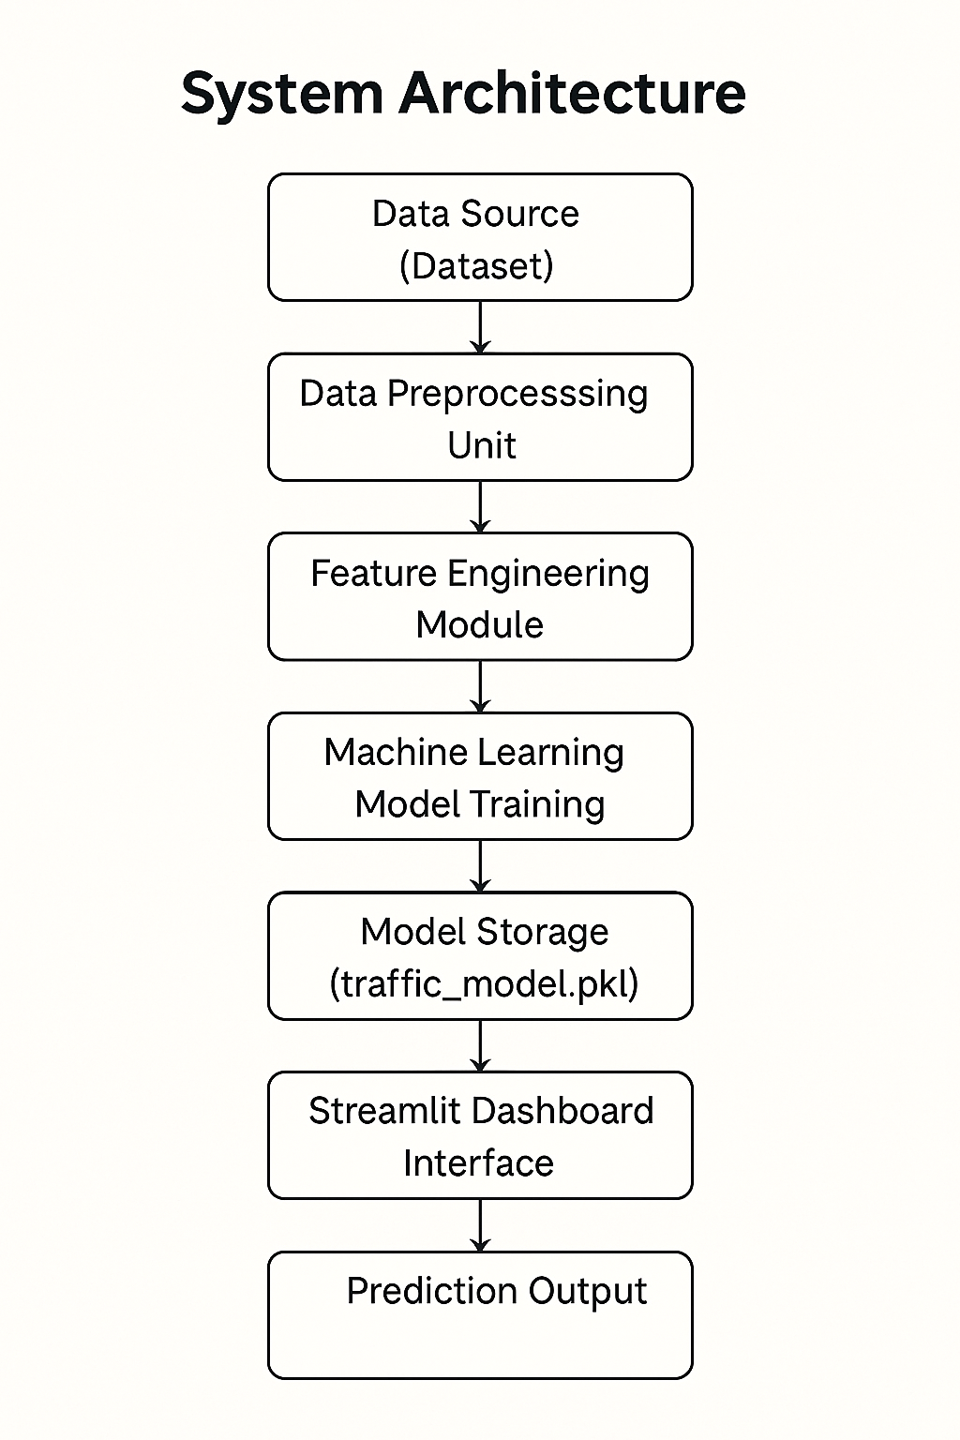
Fig.6.1 System Architecture

6.2 Data Flow Diagram (DFD)

Figure 6.2 illustrates the Data Flow Diagram of the Traffic Volume Prediction System, showing how information moves between different components of the application. The diagram begins with the User Input Interface, where users enter weather parameters such as temperature, rainfall, snowfall, cloud percentage, and time-related attributes.
These inputs are passed to the Preprocessing Block, which cleans, formats, and converts the raw user data into the structured numerical format required by the prediction model.

Once preprocessing is completed, the transformed input is forwarded to the Machine Learning Model (Random Forest). This model analyzes the processed features, applies the learned patterns from historical data, and generates a predicted traffic volume for the given conditions.

The prediction value is then sent to the Output Display Module, where the system interprets the numerical result, categorizes the traffic level (Low, Medium, or High), and presents the final outcome on the Streamlit dashboard.

The DFD highlights the smooth and systematic movement of data from user interaction to backend processing and finally to output visualization.
It reflects how each module performs a specific function yet stays interconnected, ensuring accurate prediction and real-time feedback for the end-user.

6.2 Data Flow Diagram (DFD)

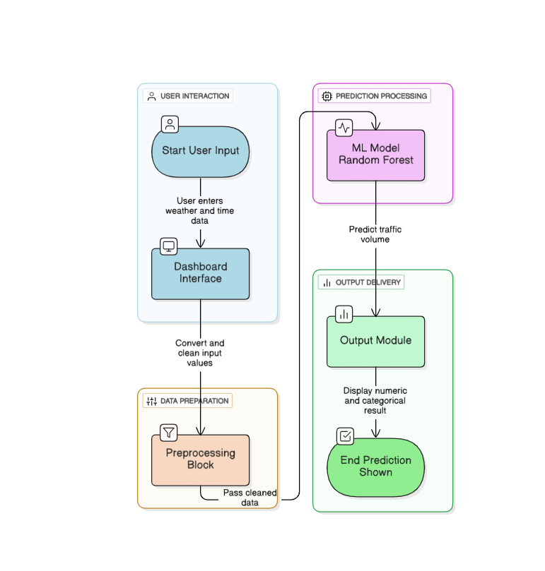

Fig.6.2 Data Flow Diagram

6.3 Use Case Diagram

Figure 6.3 illustrates the Use Case Diagram for the Traffic Volume Prediction System, representing how a user interacts with various system functionalities. The diagram centers on a single primary actor, the user, who accesses the system through a login interface before interacting with the platform. Once authenticated, the user can enter weather- and time-based inputs, upload the dataset if required, and generate traffic predictions using the machine learning model integrated into the dashboard. The system also allows users to view dataset insights and visualizations for deeper understanding of traffic patterns. Finally, the user can log out securely once the tasks are completed.

This diagram captures the complete interaction flow and highlights how the system simplifies user engagement by offering a clear, intuitive set of operations—from data input to prediction and analysis—through a structured interface.

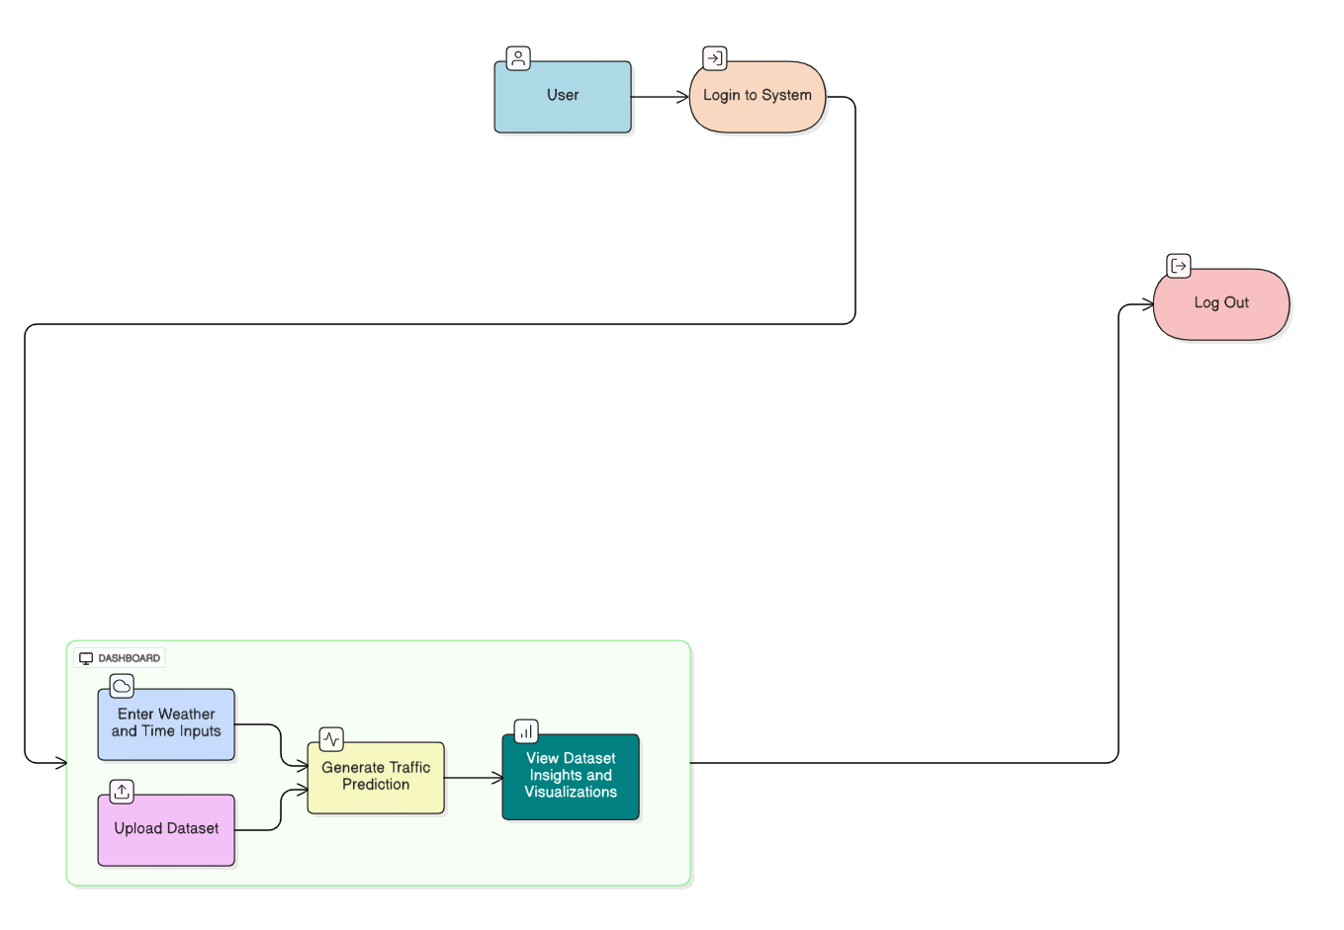
Fig.6.3 Use Case Diagram

  - Block Diagram of Prediction Workflow

Figure 6.4 shows the Block Diagram representing the internal workflow of the Traffic Volume Prediction System, outlining how data moves through different computational stages to generate accurate predictions. The process begins with the User Input Block, where the user provides essential parameters such as temperature, rain, snow, cloud percentage, hour, and weekday. These inputs move into the Preprocessing Block, which validates and formats the data to ensure consistency and compatibility with the model.

Once preprocessing is complete, the data is forwarded to the Model Loading Block, where the trained Random Forest model is retrieved from the saved .pkl file. The refined data then enters the Prediction Engine, where the model analyzes the inputs and produces a numerical traffic volume estimate. This output is transferred to the Traffic Classification Block, where it is categorized into Low, Medium, or High traffic levels based on predefined thresholds.

Finally, the results are displayed in the Output Display Block, where the system presents the predicted value and traffic category clearly on the Streamlit dashboard. This block diagram effectively illustrates the smooth transition of data from user input to final prediction, showcasing the structured and efficient workflow of the system.

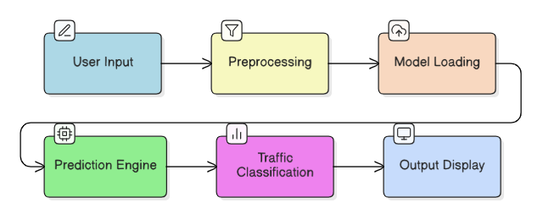
Fig.6.4 Block Diagram

CHAPTER 7: IMPLEMENTATION

The implementation phase focuses on transforming the conceptual design of the Traffic Volume Prediction System into a fully functional application. This chapter explains how the system was developed across different layers, including dataset preparation, machine learning model development, backend processing, and frontend user interface integration. The implementation ensures that the final system is accurate, scalable, and easy for end-users to operate.

7.1 Dataset Collection and Preparation
The project uses the Metro Interstate Traffic Volume Dataset, which contains traffic records collected from Minnesota, USA. The dataset includes weather details such as temperature, rain, snow, cloud coverage, and date-time information linked to traffic volume.
During implementation, the dataset was imported and examined for missing values, duplicate entries, and inconsistent records. Date-time information was expanded into separate components such as hour, day of the week, and month, enabling the model to understand hourly and seasonal traffic patterns. This structured dataset serves as the foundation for accurate traffic volume prediction.

7.1.1 Data Preprocessing
Data preprocessing ensures the dataset is suitable for model training and eliminates issues that Could affect prediction accuracy.

Key preprocessing steps included:
- Handling Missing Values: Weather readings with missing values were filled using median values or forward-filling techniques.
- Outlier Detection: Extremely large or unusual traffic values were inspected and limited to reasonable ranges.
- Feature Engineering: New features such as is_weekend were created to help the model distinguish between weekday and weekend traffic trends.
- Dataset Splitting: The dataset was divided into training and testing sets using an 80–20 ratio to evaluate how well the model performs on unseen data.
These steps ensured the model received clean, meaningful data for learning traffic behavior.

7.2 Model Development and Selection
Three machine learning models were implemented and tested:
- Linear Regression
- XGBoost Regressor
- Random Forest Regressor
Each model was trained using the same dataset, and their performance was evaluated using metrics such as MAE (Mean Absolute Error) and R² Score.
After analysis, the Random Forest Regressor demonstrated the highest accuracy and best generalization on the test dataset. Therefore, it was selected as the final prediction model. The trained model was then exported as a file so that it could be integrated into the Streamlit dashboard for real-time predictions.

7.3 System File Structure
To keep the project organized, the implementation followed a modular structure.
- Dataset (raw and cleaned files)
- Model files (trained model and thresholds)
- Streamlit application (frontend dashboard)
- Utility functions (preprocessing, prediction support)
This structure allows easy maintenance and updates in the future.

7.4 Backend Implementation
The backend is responsible for processing user inputs, loading the saved model, and generating predictions.
Core Backend Activities:
- Model Loading: The trained Random Forest model is loaded once when the application starts.
- Input Processing: When the user provides temperature, rain, snow, cloud cover, date, and hour, the system converts these inputs into the same format used during model training.
- Traffic Prediction: The processed inputs are passed to the model, which returns the expected hourly traffic volume.
- Traffic Categorization: The predicted volume is classified into Low, Medium, or High based on predefined thresholds.
7.5 Frontend Implementation
The frontend was developed using Streamlit, which allows building interactive AI dashboards easily.

Key Features of the Frontend:
- Login Page: A simple authentication screen ensures only authorized users can access the dashboard.
- User-Friendly Input Panel: Date selectors, sliders, and numeric fields allow the user to provide the required values for prediction.
- Prediction Display: The predicted traffic volume is shown visually along with a colored label indicating traffic level (Low/Medium/High).
- Dataset Overview: The dashboard also includes dataset previews and basic graphs to help users understand traffic patterns.
The user interface is designed with a royal blue theme and white text to give the dashboard a professional and clean appearance.

7.6 Integration of Frontend and Backend
Once the model, input-processing functions, and dashboard UI were ready, they were integrated to create a unified system.

The integration workflow is:
- User enters inputs through the Streamlit UI.
- Inputs are sent to backend preprocessing functions.
- The trained model predicts traffic volume.
- The frontend displays results in real time.
This seamless flow ensures the user receives quick and accurate predictions with minimal
complexity.

7.7 Challenges in Implementation

During the development of the Traffic Volume Prediction System, several challenges were encountered. These issues required careful troubleshooting and adjustments to ensure the system functioned smoothly.

1. Data Quality Issues
The dataset contained missing values, inconsistent weather readings, and some extreme outliers in traffic volume. Cleaning and preprocessing required multiple steps to ensure accurate model training.

2. Feature Engineering Complexity
Extracting meaningful features from the date-time column, such as hour, day of week, and month, required careful conversion and verification so that the model could understand traffic patterns correctly.

3. Model Performance Tuning
Comparing different models such as Linear Regression, XGBoost, and Random Forest took time. Several experiments were needed to find the best parameters and choose the most accurate model.

4. Integration with Streamlit
Connecting the trained machine learning model with the Streamlit frontend posed some difficulties. Ensuring smooth data flow between user inputs, backend processing, and prediction display required debugging.

5. UI Design Adjustments
Implementing the desired UI theme (royal blue background, white text, modern layout) required multiple CSS adjustments because Streamlit has limited built-in styling features.

6. Handling External Libraries
Some libraries, such as XGBoost or Streamlit experimental features, caused installation or compatibility issues, especially inside the virtual environment. These needed manual fixes.

7.8 Snapshot

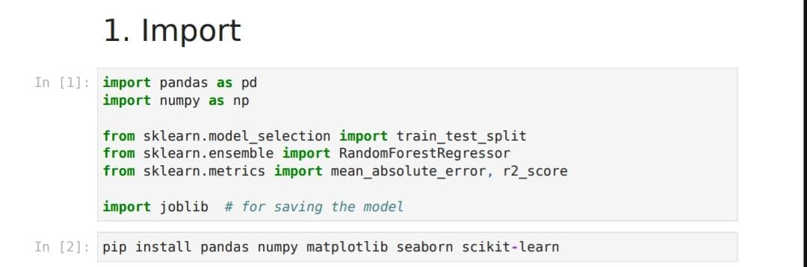
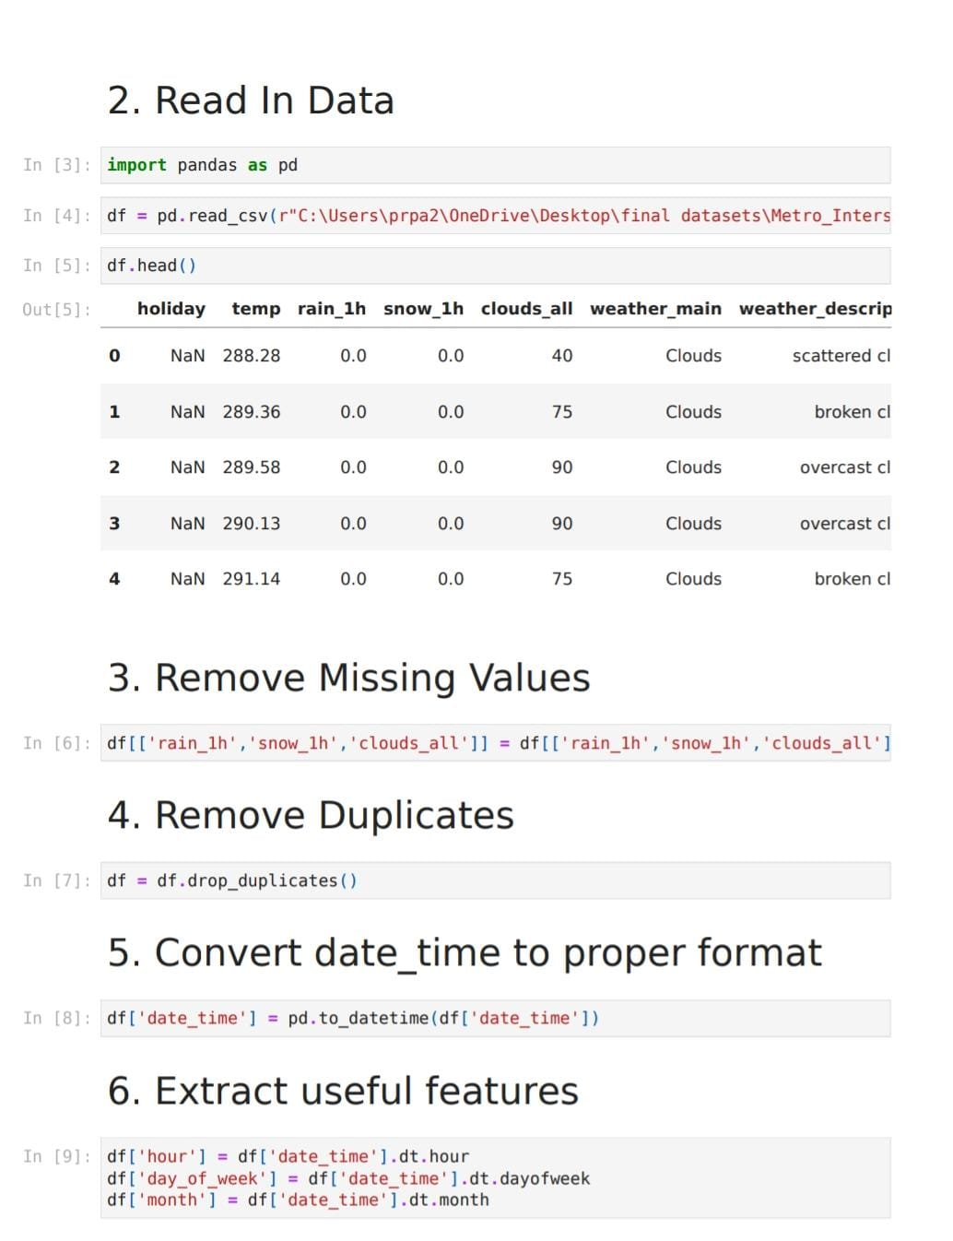
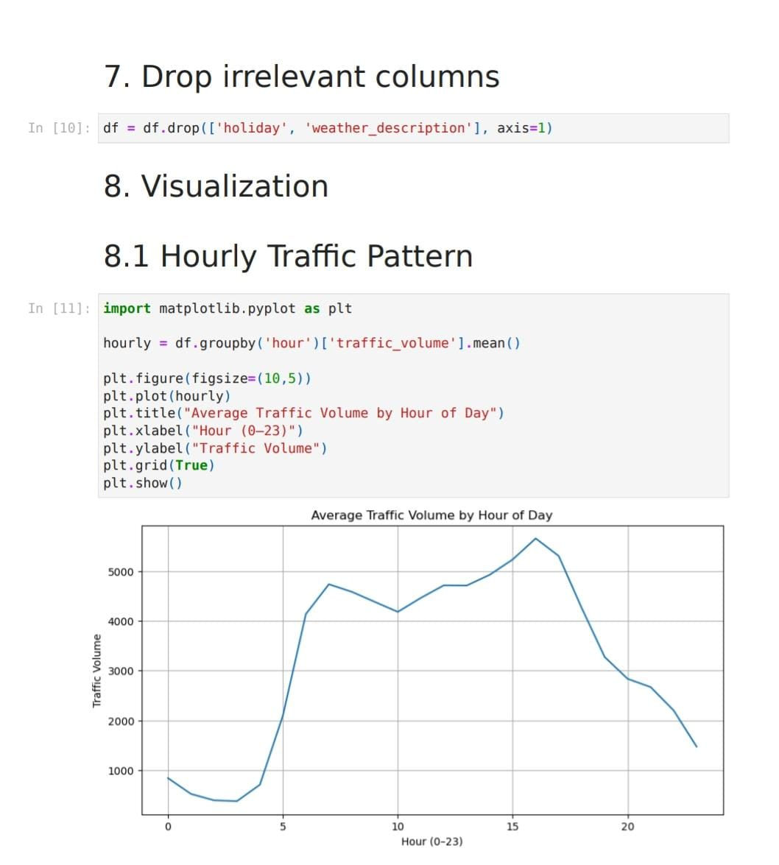
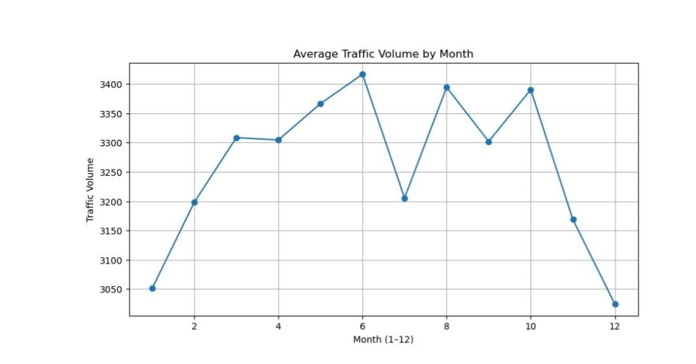

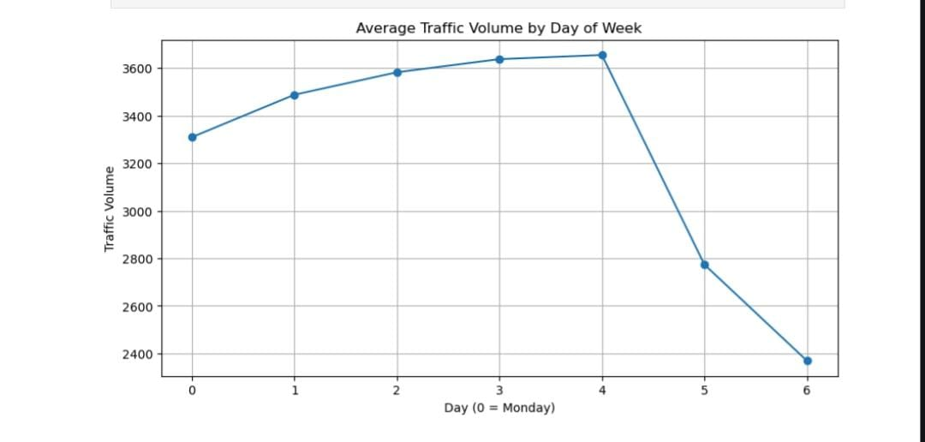

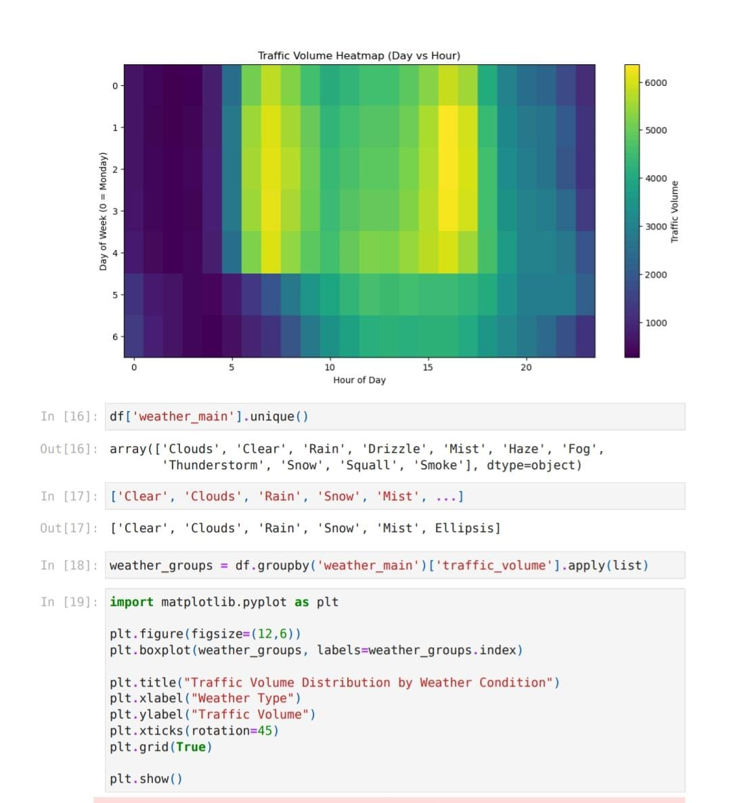

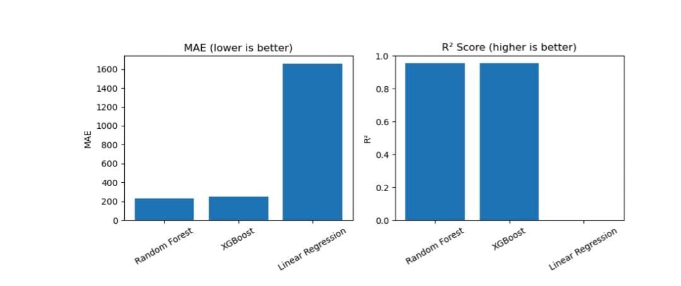

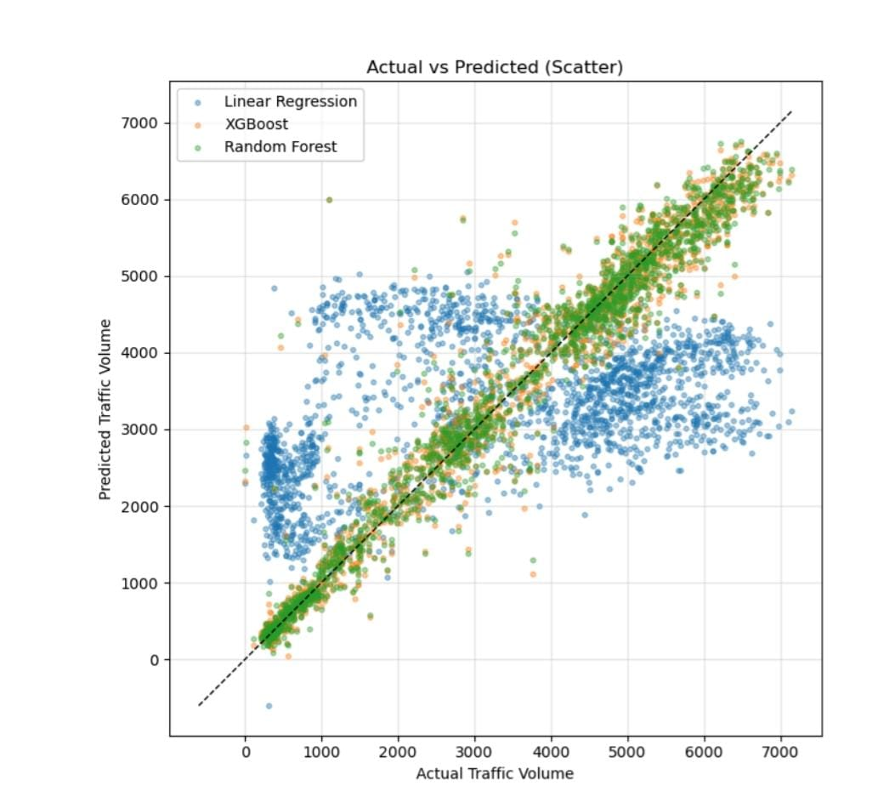

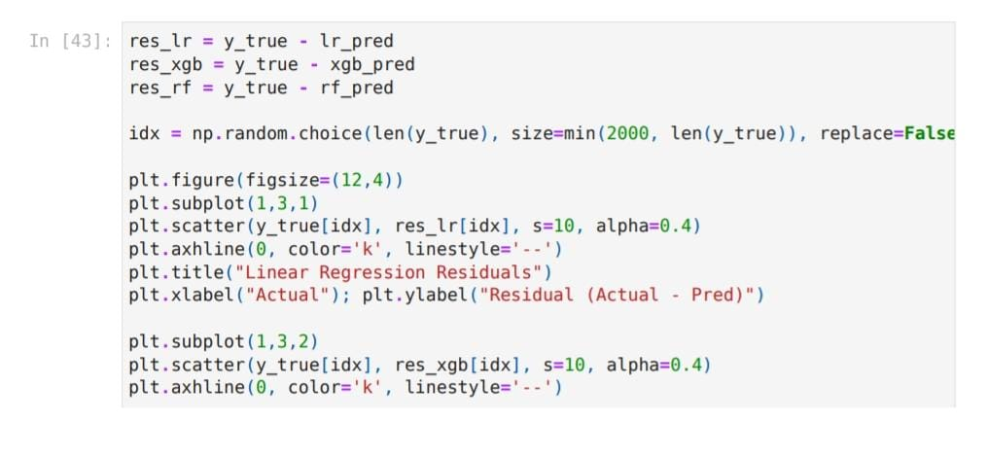

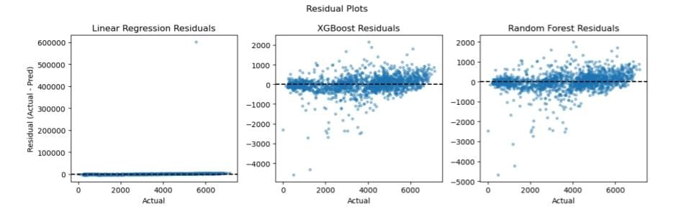

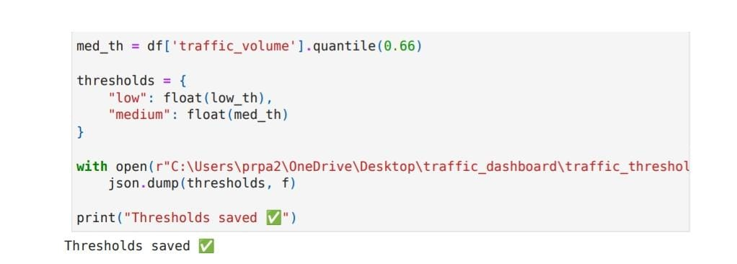

CHAPTER 8 TESTING

8.1 Testing
Testing is an essential phase in software development, ensuring that the system performs as intended and meets all functional requirements. The Traffic Volume Prediction System underwent multiple levels of testing to validate correctness, reliability, user interaction, and overall system stability. This chapter outlines the different testing methods applied to both the machine learning model and the Streamlit dashboard.

8.1.1 Unit Testing
Unit testing was carried out on individual components of the system, focusing on small, isolated units such as preprocessing functions, input validation logic, and model loading functions.
Key elements tested:
- Conversion of date-time values into hour, weekday, and month
- Handling of missing or invalid inputs
- Proper loading of the trained Random Forest model
- Threshold application for Low, Medium, and High traffic categories
Unit testing ensured that each function behaved correctly before integrating it into the full system.

8.1.2 Model Testing
The performance of the machine learning models was tested using the reserved test dataset .
Model testing involved:
- Predicting traffic volume using unseen data
- Comparing predicted results with actual recorded traffic
- Calculating performance metrics such as Mean Absolute Error (MAE) and R² Score
Among the three models tested (Linear Regression, XGBoost, Random Forest), the Random Forest model demonstrated the highest accuracy and most stable predictions.
This evaluation confirmed that the selected model was suitable for deployment.

8.1.3 Integration Testing
Integration testing focused on verifying the interaction between different system components:
- Connection between the dashboard frontend and prediction backend
- Smooth flow of user inputs into preprocessing functions
- Correct passing of processed data into the model
- Appropriate formatting of prediction results displayed to the user
This testing ensured that once components were combined, they operated seamlessly without causing errors or delays.

8.1.4 User Interface Testing
The Streamlit dashboard was tested for usability, layout, and responsiveness.
Testing included:
- Verifying the alignment and functionality of input fields
- Checking if the prediction result card updates instantly after input changes
- Ensuring the dashboard loads correctly across different screen sizes
- Testing the login flow for correct authentication
UI testing confirmed that the system provides a smooth and intuitive experience for the end user.

8.1.5 Functional Testing
Functional testing validated whether the system meets expected requirements and performs the tasks it was designed for.
Key functional checks:
- Accurate prediction of traffic volume
- Correct classification into Low, Medium, High levels
- Proper response to extreme or unusual input values
- Successful dataset upload and display within the dashboard
All functions operated as expected, verifying that the system fulfills the project's objectives.

8.1.6 Error Handling and Validation Testing
The system was tested for how well it handles invalid or missing user inputs, incorrect data formats, and unexpected values.
Examples tested:
- Inputting negative temperature or impossible weather values
- Leaving required fields empty
- Uploading unsupported dataset formats

8.1.7 Performance Testing
Although the system is lightweight, basic performance testing was conducted:
- Time taken to load the model
- Responsiveness of the dashboard under multiple input changes.

Dashboard :

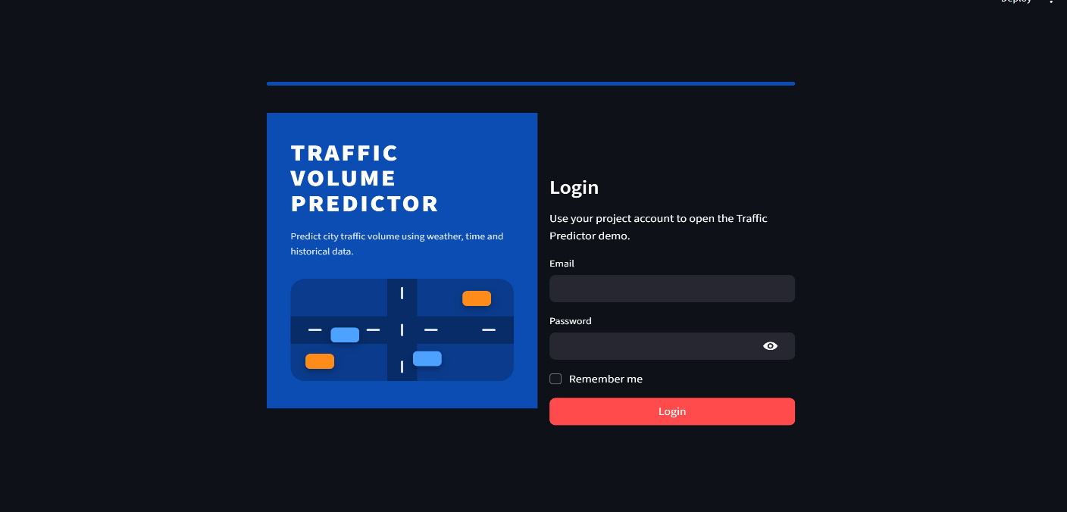

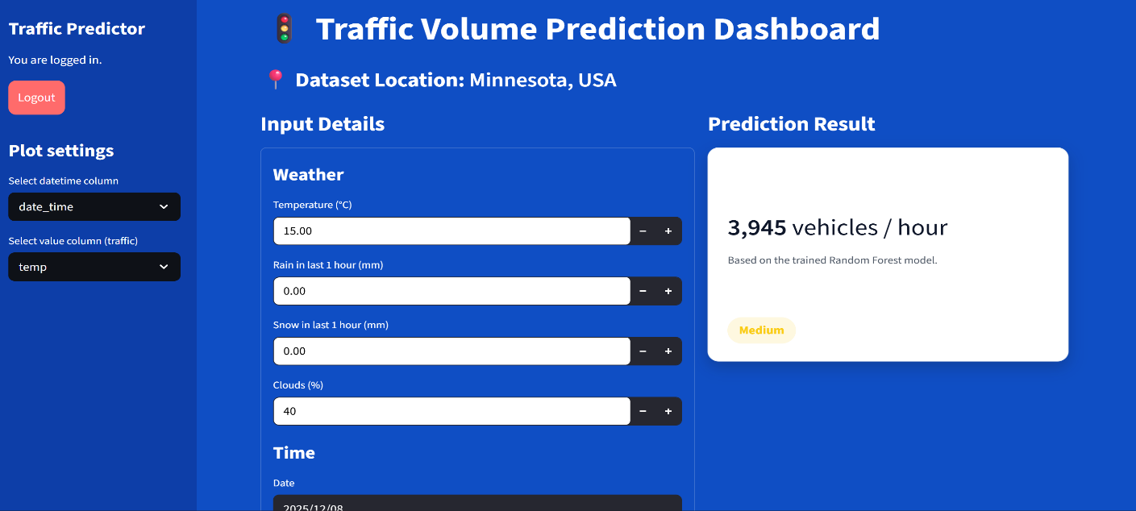

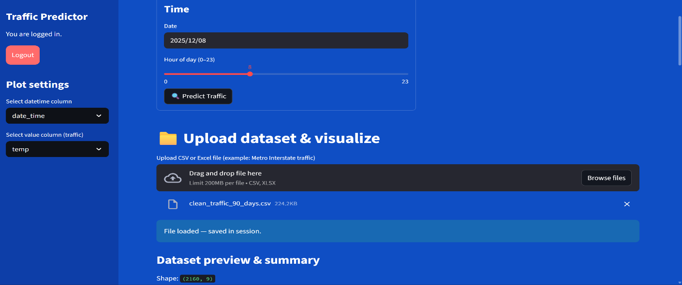

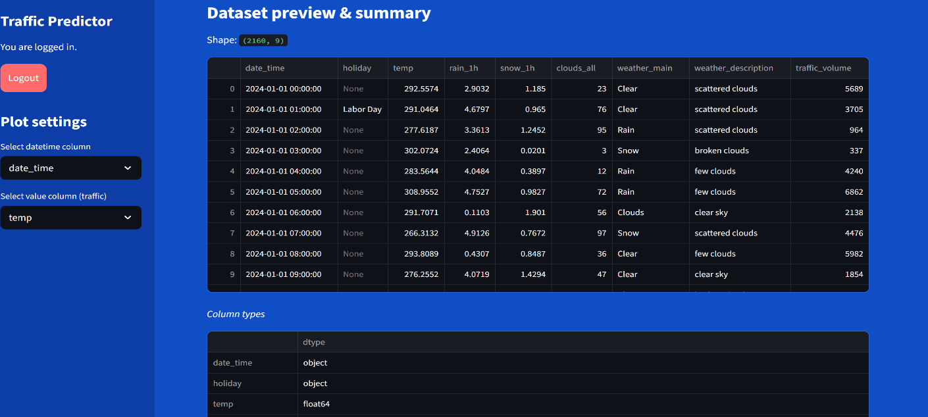

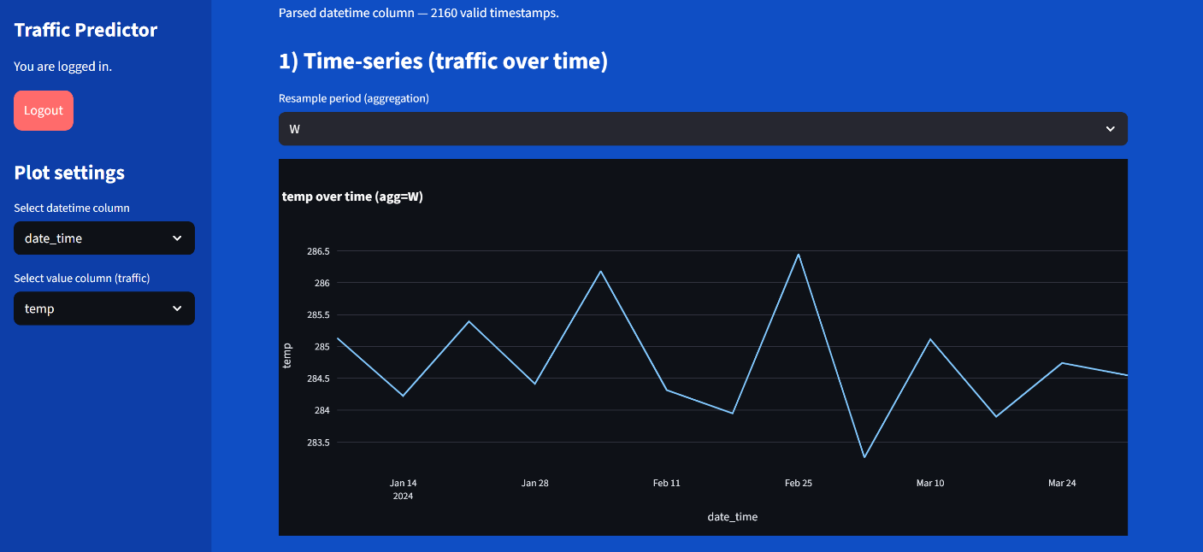

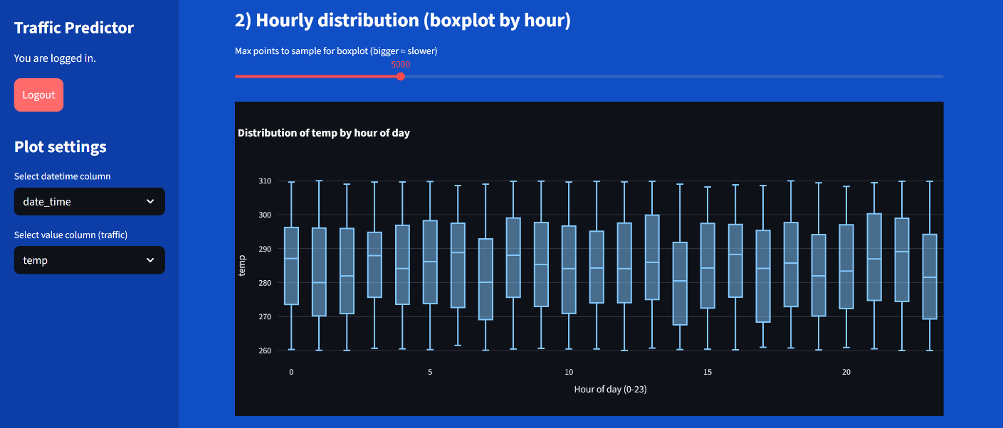

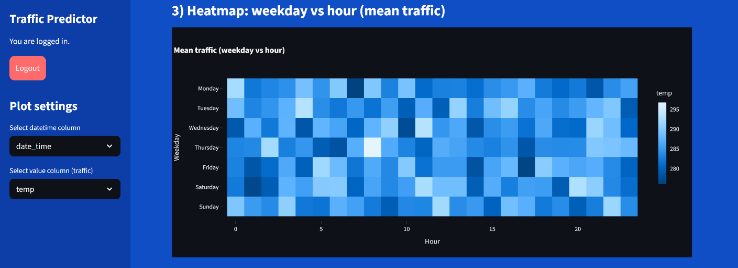

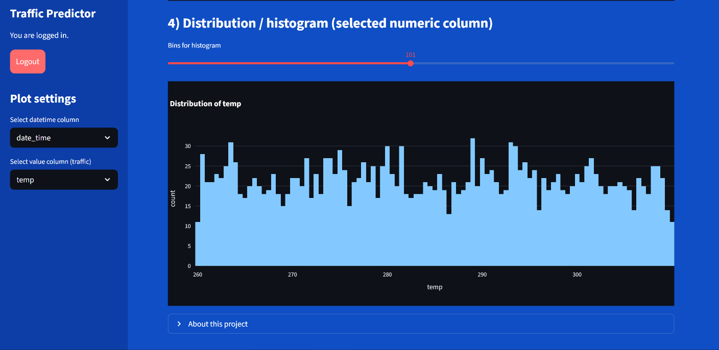



CHAPTER 9: CONCLUSION & FUTURE SCOPE

9.1 Conclusion

The Traffic Volume Prediction System developed in this project successfully demonstrates how machine learning can be used to forecast urban traffic conditions based on weather and time-related factors. By using the Metro Interstate Traffic Volume Dataset, the system analyzes the influence of temperature, rainfall, snow, cloud cover, and temporal patterns on traffic volume.

Through systematic data preprocessing, feature engineering, and model comparison, three algorithms were implemented—Linear Regression, XGBoost, and Random Forest.

After evaluation, the Random Forest Regressor was selected as the final model due to its strong accuracy and ability to capture non-linear traffic behavior.

The system was deployed using a Streamlit-based dashboard, providing users with an intuitive interface to input custom weather and time values. The dashboard instantly generates traffic predictions and categorizes them into Low, Medium, or High, enabling practical and user-friendly interaction.

Additional features such as dataset upload, visual analytics, and login authentication further enhance the functionality of the system.

Overall, the project fulfills its objective of building a reliable, easy-to-use traffic volume prediction tool. It demonstrates the potential of machine learning in supporting urban mobility, transportation planning, and intelligent decision-making.

9.2 Future Scope

The Traffic Volume Prediction System developed in this project provides a strong foundation, but there are numerous possibilities for expansion and enhancement. As traffic patterns evolve and smart cities continue to adopt advanced technologies, the system can be upgraded to deliver more accurate, real-time, and context-aware predictions. The following future scope areas describe how the system can be further improved:

1. Integration of Real-Time Traffic and Weather Data
Currently, the system uses historical data for predictions. In the future, integrating live data streams from traffic sensors, GPS devices, or government traffic APIs can transform the system into a real-time forecasting tool.
Platforms like Google Maps API, HERE Traffic API, or city IoT sensor networks can make the system highly dynamic and practical for public use.

2. Advanced Deep Learning Models for Prediction
While Random Forest performed well, deep learning models can capture long-term and highly non-linear traffic behavior.
These models can handle large datasets, learn more complex dependencies, and potentially outperform traditional machine learning algorithms.

3. Multi-Location Traffic Prediction System
By extending the dataset and using location-based features (latitude, longitude, road ID), the system could serve as a comprehensive traffic monitoring platform for smart cities.

4. Mobile Application Development
To increase accessibility, the prediction system can be converted into a mobile app.
This would make the system more useful for daily commuters.

REFERENCES

UCI Machine Learning Repository

Reference: UCI Repository – Metro Interstate Traffic Volume Dataset
Description: The primary dataset used in this project was obtained from the UCI Machine Learning Repository.It contains hourly traffic volume readings recorded in Minnesota, USA, along with weather conditions such as temperature, rain, snow, and cloud coverage.

Pandas Library

Reference: Pandas Documentation – https://pandas.pydata.org
Description: Pandas is a Python library used for data manipulation and analysis.
In this project, it was essential for tasks such as dataset loading, cleaning, handling missing values, feature engineering, and preparing data for machine learning models.

NumPy Library

Reference: NumPy Documentation – https://numpy.org
Description: NumPy provides support for numerical computations and array operations.

Scikit-learn Library

Reference: Scikit-learn Documentation – https://scikit-learn.org
Description: Scikit-learn is a widely used machine learning library in Python.
It supported the implementation of Linear Regression, Random Forest.

XGBoost Library

Reference: XGBoost Documentation – https://xgboost.readthedocs.io
Description:XGBoost is an optimized gradient boosting framework used for building high-performance machine learning models.

Matplotlib & Seaborn

Reference: Matplotlib and Seaborn Documentation – https://matplotlib.org / https://seaborn.pydata.org
Description: These visualization libraries were used to create graphs such as hourly traffic trends, box plots, scatter plots, and model comparison figures.

Joblib Library

Reference: Joblib Documentation – https://joblib.readthedocs.io
Description: Joblib was used for saving and loading the trained Random Forest model (traffic_model.pkl).

Streamlit Framework

Reference: Streamlit Documentation – https://docs.streamlit.io
Description: Streamlit is a Python framework used to build data-driven web applications.
In this project, it was used to create the interactive dashboard, handle user inputs, display predictions, visualize datasets, and design the login interface.

JSON Module

Reference: Python Standard Library Documentation
Description: The JSON module was used to store and retrieve predefined traffic thresholds for Low, Medium, and High categories.

Python Programming Language

Reference: https://www.python.org
Description: Python served as the primary programming language for data preprocessing, model training, backend logic, and dashboard implementation.
Its versatility and rich ecosystem of libraries made development efficient.

Academic Research Papers on Traffic Prediction

Reference: Journals such as Transportation Research Part C, Springer, Elsevier
Description: Research studies on traffic forecasting, statistical modeling, and weather influence helped guide the selection and justification of algorithms like Random Forest and XGBoost.

ChatGPT by OpenAI

Reference: https://chat.openai.com
Description: ChatGPT assisted in drafting documentation, structuring the report, explaining concepts, and guiding implementation steps.

